1.Read about the difference between window, screen and document in javascript?

* window is the execution context and global object for that context's JavaScript
* document contains the DOM, initialized by parsing HTML
* screen describes the physical display's full screen

2. Create your own resume data in JSON format?

let resume={

name:"Hareharan",

age:21,

qualification:"BE. Mechanical",

college:"St. Josephs College of Engineering",

DOB:"16-05-2000",

hobbies:"swimming , video games , cricket",

interests:"Full stack developer"

}

console.log(resume);

3.For the given JSON iterate over all for loops (for, for in, for of, forEach)?

* For loop:
* For in loop:
* For of loop:
* For Each loop:

For loop:

let countries=[

{

name:"India",

population:"1.3 Billion",

flag:"Tricolor",

capital:"Delhi"

},

{

name:"China",

population:"1.5 Billion",

flag:"Red flag with a star",

capital:"Beijing"

},

{

name:"Sri Lanka",

population:" 45 Million",

flag:" Yellow flag with a lion in it",

capital:"Colombo"

}];

for(var i =0;i<countries.length;i++){

console.log(countries[i].name);

}

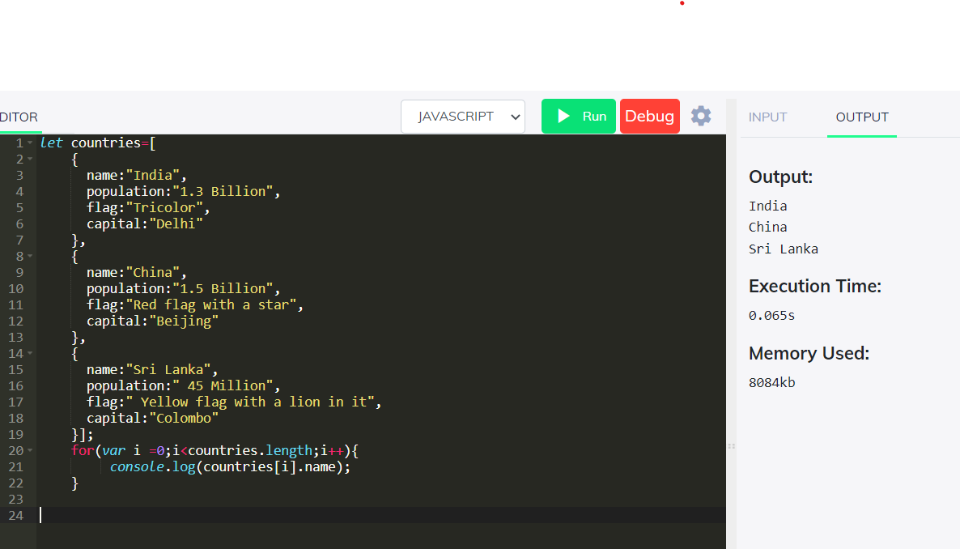

For in loop:

let countries=[

{

name:"India",

population:"1.3 Billion",

flag:"Tricolor",

capital:"Delhi"

},

{

name:"China",

population:"1.5 Billion",

flag:"Red flag with a star",

capital:"Beijing"

},

{

name:"Sri Lanka",

population:" 45 Million",

flag:" Yellow flag with a lion in it",

capital:"Colombo"

}];

for(let i in countries){

console.log(countries[i].name + " = " + countries[i].population);

}

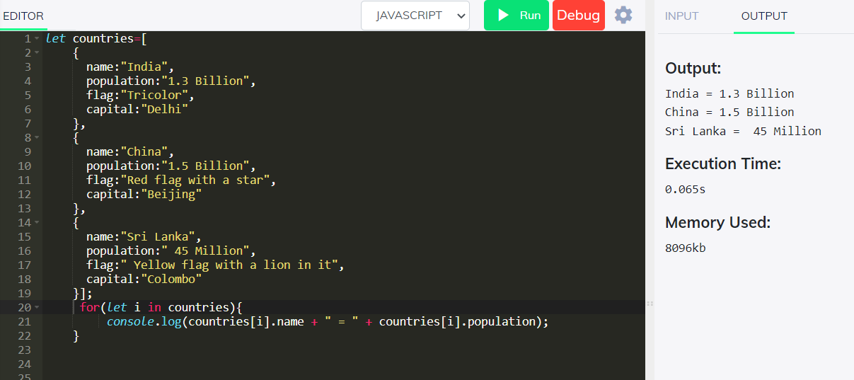

For of loop:

let arrCountries=[

{

name:"India",

population:"1.3 Billion",

flag:"Tricolor",

capital:"Delhi"

},

{

name:"China",

population:"1.5 Billion",

flag:"Red flag with a star",

capital:"Beijing"

},

{

name:"Sri Lanka",

population:" 45 Million",

flag:" Yellow flag with a lion in it",

capital:"Colombo"

}];

for(let countries of arrCountries){

console.log(countries.name + "'s capital is : "+ countries.capital);

}

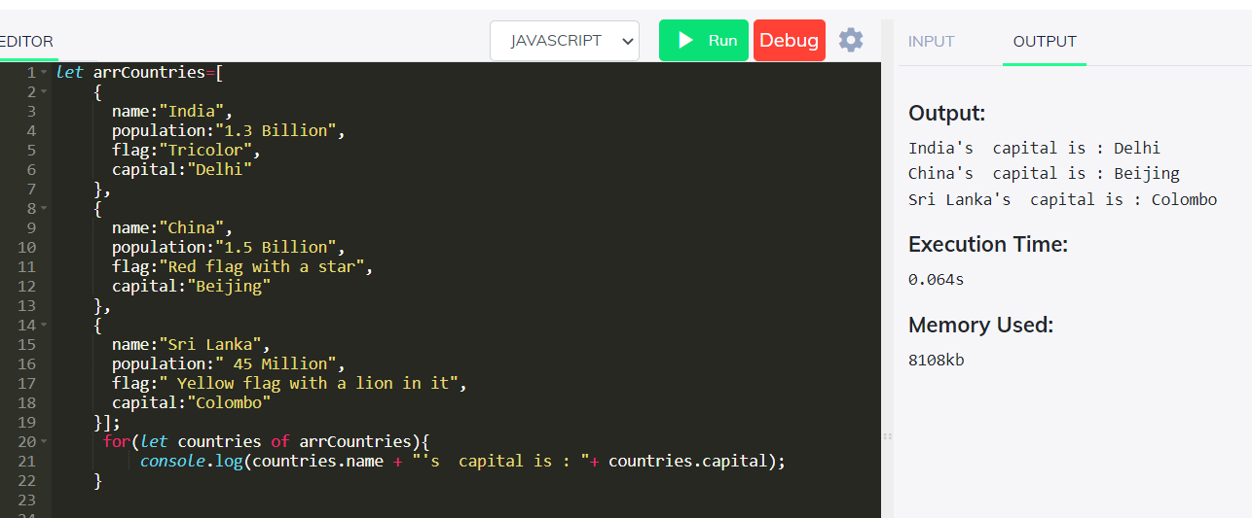

For Each loop:

let arrCountries=[

{

name:"India",

population:"1.3 Billion",

flag:"Tricolor",

capital:"Delhi"

},

{

name:"China",

population:"1.5 Billion",

flag:"Red flag with a star",

capital:"Beijing"

},

{

name:"Sri Lanka",

population:" 45 Million",

flag:" Yellow flag with a lion in it",

capital:"Colombo"

}];

arrCountries.forEach(function(country){

console.log(country.name);

});

